

**DEPARTMENT OF COMPUTER SCIENCE**

**CERTIFICATE**

This is to certify that the project titled “**SOCIETY CONNECT: A SMART APARTMENT MANAGEMENT APP”** is the record work done by the candidates themselves under our guidance during the period of study and that to the best our knowledge and that it has not previously formed the basis of the award of degree or diploma in Goa University or elsewhere.

**Ms. Likita S. Shetty External Examiner**

**INTERNAL GUIDE**

**Ms. Ana Gracy Fernandes Dr. Pravina Kerkar HEAD OF THE DEPARTMENT PRINCIPAL - INCHARGE**

**DECLARATION**

We declare that this project report entitled **SOCIETY CONNECT: A SMART APARTMENT MANAGEMENT APP**

Has been composed by us and it has not previously formed the basis for the award of any degree or order similar titled and is purely original.

**T.Y.B.S.C**

**(COMPUTER SCIENCE)**

**2021-2022**

1. **SMITA A. DIKE S19-308**
2. **DIPANKAR S. JADHAV S19-377**
3. **SMILEE LOPES S19-479**
4. **AASTHA A. SANGLE S19–481**

**ACKNOWLEDGEMENT**

We take this opportunity to express our greatest appreciation to all the individuals who have helped and supported us in every stage of this project. First and foremost, I would like to thank our Associate Professor Ms. Sujata R. Gaonkar under whose supervision we were able to initiate our idea of the project. Our project guide Ms. Likita S. Shetty has given us undivided support and guidance which inspired and encouraged us throughout the project. This project has been a source to learn and bring out our theoretical knowledge to the real-life world. So, we really acknowledge the help and guidance for this project. The motivation and help contributed tremendously to the successful completion of the project.

We owe our gratitude to Goa University for giving us the opportunity to prove our abilities. We express our deepest gratitude to Government College of Arts, Science & Commerce, Khandola-Marcela Goa for providing us with necessary facilities, support and much needed motivation. We are also grateful to our Head of Department Mrs. Anna B. Gracy Fernandes and all the teaching staff members from the Department of Computer Science for their precious help and support.

We would also like to express our gratitude to our Principal Dr. Purnakala Samant and Principal-Incharge Dr. Pravina Kerkar who has encouraged and given us an opportunity to showcase our ability through this project

We thank the members of our family for their support and encouragement. Last but not the least we would like to thank our almighty for his pure love and care towards us.

TABLE OF CONTENTS

1. **Introduction………………………………………………...01**

1.1 Society Management System…………………………...02

1. **Project Description.………………………………………..03**

2.1 Society Connect………………………………………...04

1. **Technologies Used………………………………………….06**
   1. *Web Technology*..……………………………………...07
      1. Inkscape………………………………………...07

3.1.2 Canva…………………………………………...08

* 1. *Cloud Technology*…………………………………….. 09
     1. Firebase………………………………………...09
     2. Firebase Authentication………………………...10
     3. Cloud Firestore……………………..…………..11

3.2.4 Firebase Realtime Database……………………..12

3.2.5 Cloud Storage………………...…………………13

* 1. *Google Services*………………………………………..14

3.3.1 Android Studio………………………………….14

* + 1. Google Cloud Platform…………………………17

3.3.3 SQLite Database………………………………..18

1. **Libraries and Packages…………………………………….19**

4.1 Firebase Authentication………………………………...20

4.2 Realtime Database……………………………………...20

4.3 Cloud Firestore…………………………………………20

4.4 Cloud Storage…………………………………………..20

1. **Project Overview……………………………………………21**
2. **Data Handling………………………………………………24**

6.1 Data Flow Diagram (DFD)……………………………..25

6.2 Use Case Diagram………………………………………27

1. **User Manual…………………………………………………28**
2. **Future Enhancement………………………………………..48**
3. **Bibliography…………………………………………………50**



INTRODUCTION

**1. INTRODUCTION**

**1.1 SOCIETY MANAGEMENT SYSTEM**

Everyday life in city areas has important things to deal with society management. A society has several needs - maintenance collection, communication among residents, repairs and maintenance of assets, tracking staff, managing visitors, parking, security, parcels and many more things which directly or indirectly plays the vital role in residential life.

In most of the cases, society management practices a traditional way of communication. This certainly has some limitations. Daily notices, monthly meetings, cultural events, emergency contacts for daily needs, security alerts, high priority communication and many others which may not be conveyed properly in current scenario as most of the things are getting handled manually. To overcome the problems occurring due to this time lagging manual system, an automated system needs to be developed to reduce the human efforts.

The society management system will computerize and centralize all day-to-day operations in the society. It effectively manages and handles all the functioning of a cooperative society. The software system can store the data of various flat owners.



PROJECT

DESCRIPTION

**2. PROJECT DESCRIPTION**

**2.1 SOCIETY CONNECT: A SMART APARTMENT**

**MANAGEMENT APP**

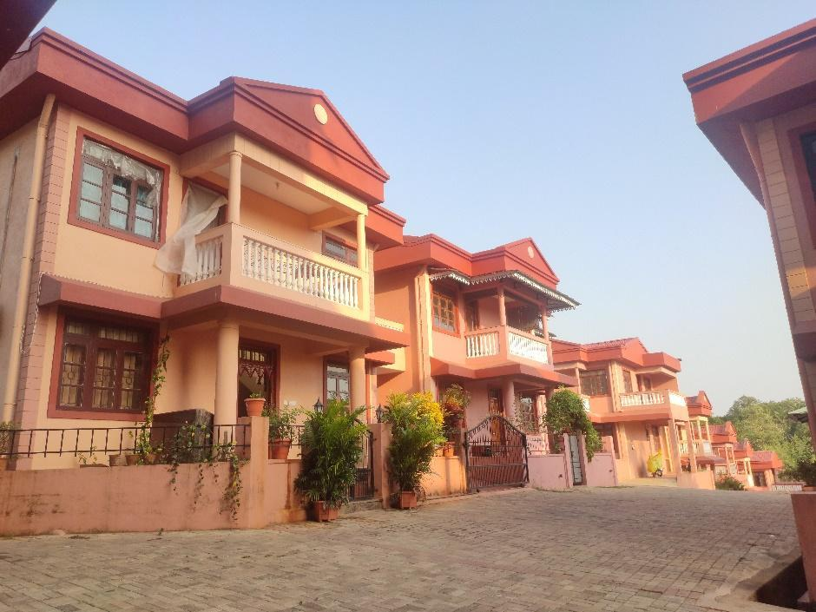

In this era, people are so busy with their routine work that they do not have time to cope up with their hectic schedules and make time for various necessities such as complain about small problems related to any issues.

With **SOCIETY CONNECT** App, we have a cloud-based system to manage all the day-to-day activities of the society. This user-friendly system allows users to slide through the images and track the live location (Google Maps) of the society on the homepage. The different functionalities like complaints, meetings, notices, emergency contacts will be available within a single sight so that user can observe it and make use of it whenever it is necessary.

In order to become a member and get access to all the features of the system the users will have to first register themselves and login with their respective credentials.

All the society events can be managed online with all the details like events organised by, occasion, venue through circulars and so on. We have developed the system for society members to keep the records of all the visitors coming to the society, parking for the flat owners, guest parking, vendors coming to the society and various deliveries. The system also has a feature where the society members can make complaints anywhere and at anytime. The members can also check the availability of the working staff.



TECHNOLOGIES USED

**3. TECHNOLOGIES USED**

**3.1 WEB TECHNOLOGY**

**3.1.1 INKSCAPE**

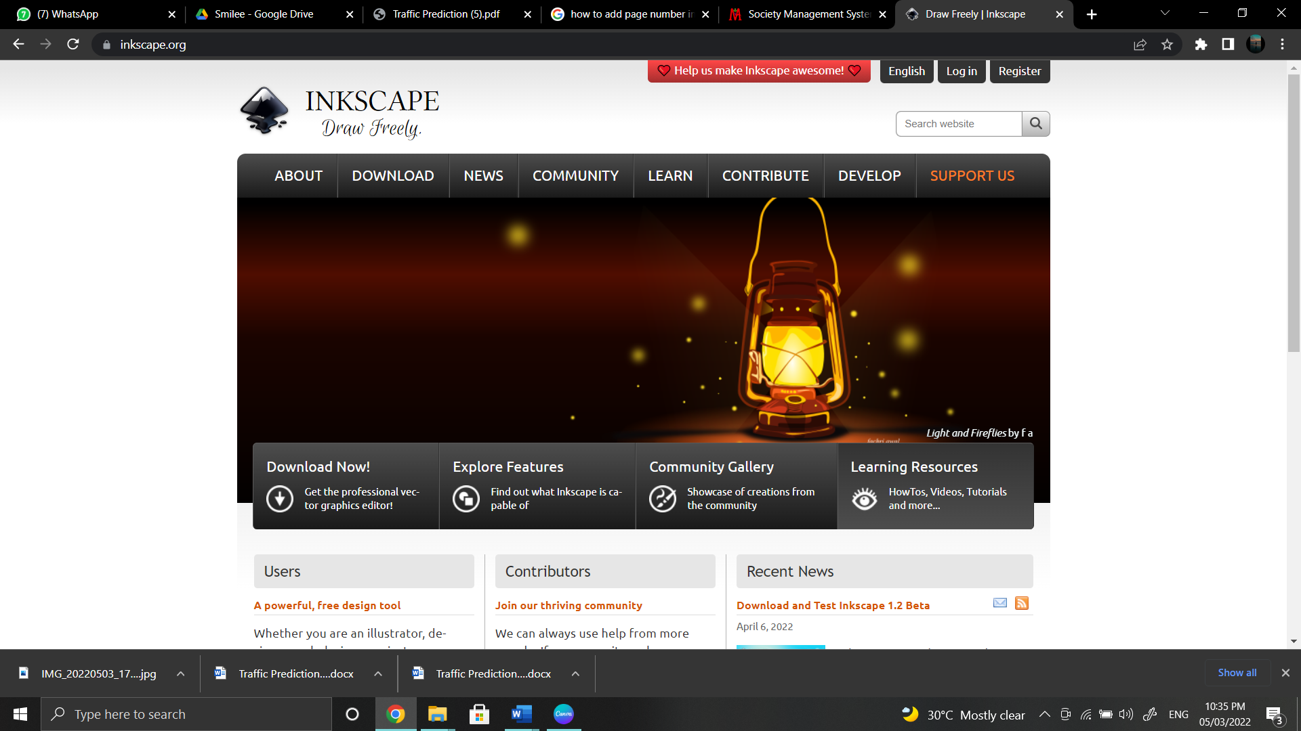

**Inkscape** is a [free and open-source](https://en.wikipedia.org/wiki/Free_and_open-source_software) [vector graphics editor](https://en.wikipedia.org/wiki/Vector_graphics_editor) used to create [vector images](https://en.wikipedia.org/wiki/Vector_images), primarily in [Scalable Vector Graphics](https://en.wikipedia.org/wiki/Scalable_Vector_Graphics) (SVG) format. It offers a rich set of features and is widely used for both artistic and technical illustrations such as cartoons, clip art, logos, typography, diagramming and flowcharting. It uses vector graphics to allow for sharp printouts and renderings at unlimited resolution and is not bound to a fixed number of pixels like raster graphics. Inkscape uses the standardized SVG file format as its main format, which is supported by many other applications including web browsers. It can also import and export various file formats, including SVG, AI, EPS, PDF, PS and PNG.

**3.1.2 CANVA**



**Canva** allows for image editing and project-based learning using a simple drag-and-drop interface. It is a free graphic design platform that allows to easily create invitations, business cards, flyers, lesson plans, Zoom backgrounds, and more using professionally designed templates.

The photos can be uploaded to Canva's templates using it’s drag and drop interface. It's open source and doesn't require extensive photo editing knowledge to use.

**3.2 CLOUD TECHNOLOGY**

**3.2.1 FIREBASE**



**Google Firebase** is a Google-backed application development software that enables developers to develop iOS, Android and Web Apps. **Firebase** is a Backend-as-a-Service (Baas). It provides developers with a variety of tools and services to help them develop quality apps, grow their user base, and earn profit. It is built on Google’s infrastructure.

Firebase is categorized as a [NoSQL](https://www.educative.io/edpresso/whats-the-difference-betweensql-and-nosql) database program, which stores data in JSON-like documents.

**3.2.2 FIREBASE AUTHENTICATION**

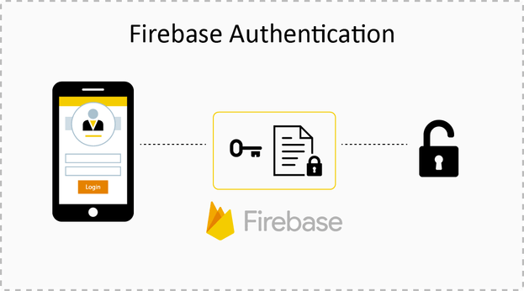

Most apps need to know the identity of a user. Knowing a user's identity allows an app to securely save user data in the cloud and provide the same personalized experience across all of the user's devices.

**Firebase Authentication** provides backend services, easy-to-use SDKs, and ready-made UI libraries to authenticate users to your app. It aims to building secure authentication systems easy, while improving the sign-in and onboarding experience for end users. It supports authentication using passwords, email and phone auth, popular federated identity providers like Google, Facebook and Twitter, and more.

**3.2.3 CLOUD FIRESTORE**

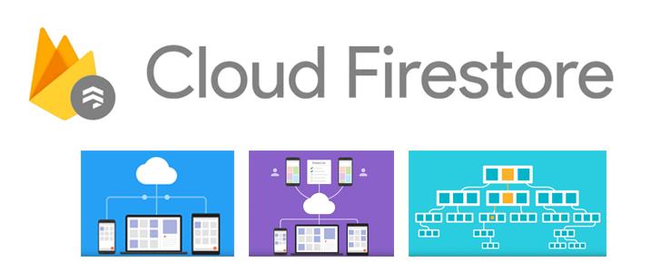

**Google Firestore**, also known as **Cloud Firestore** is a part of the Google Firebase application development platform. It isbuilt for automatic scaling, high performance, and ease of application development. It is fundamentally a cloud-hosted NoSQL database for storing and syncing data at a global scale.

Firestore can be directly accessed by mobile and web applications through native SDKs. Firestore helps to sync data across multiple client applications with the use of real-time listeners. It uses the Cloud Identity, and Access Management features from Google for the process of authentication. Firestore performs data storage in the form of documents, with the documents being stored in collections.

**3.2.4 FIREBASE REALTIME DATABASE**

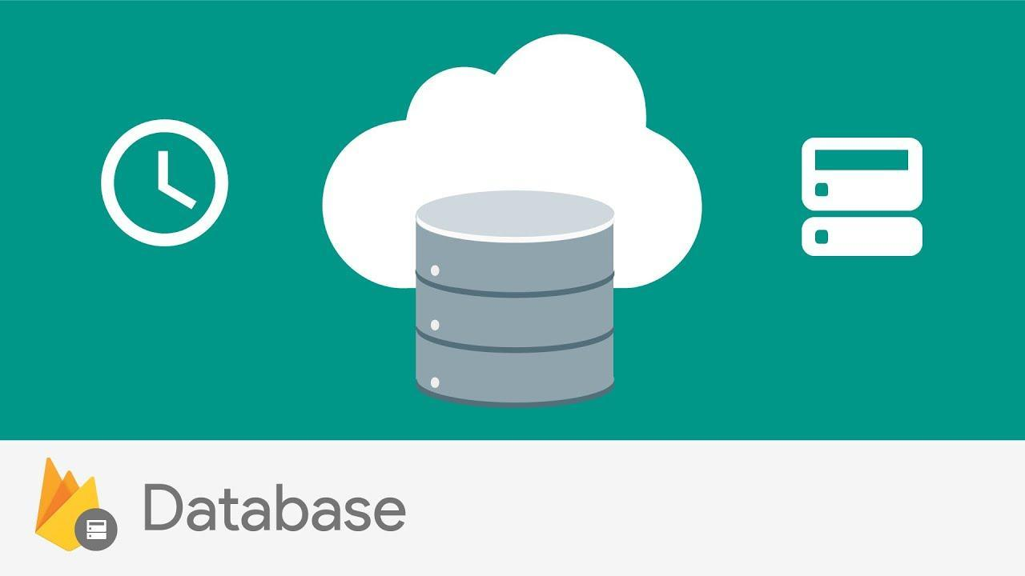

The Firebase Realtime Database is a cloud-hosted database in which data is stored as JSON. The data is synchronized in real-time to every connected client. All the clients share one Realtime Database instances and automatically receive updates with the newest data, when built cross-platform applications with iOS, and JavaScript SDKs. It allows data to be stored securely on Google cloud servers and synchronized in realtime across all clients sharing the same database.

It is a NoSQL database and acts as a big JSON object which the developers can manage in real-time. By using a single API, the Firebase database provides the application with the current value of the data and updates to that data. Real-time syncing makes it easy for the users to access their data from any device, be it web or mobile.

**3.2.5 CLOUD STORAGE**

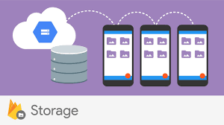

**Firebase Cloud Storage** is a modern technology that allows for storing and managing various media content generated by mobile app users. It is a powerful, simple, and cost-effective object storage service built for Google scale.

The Firebase SDKs for Cloud Storage add Google security to file uploads and downloads for your Firebase apps, regardless of network quality.

We can use our SDKs to store images, audio, video, or other user-generated content. One of its biggest advantages is reliability. Firebase SDK for Cloud Storage works regardless of the network quality. in other words, if a file stops uploading because of slow Internet connection, the process will be automatically restarted.

**3.3 GOOGLE SERVICES**

**3.3.1 ANDROID STUDIO**



**Android Studio** is the official Integrated Development Environment (IDE) for android application development. Android Studio provides more features that enhance our productivity while building Android apps.

**Features of Android Studio**

* It has a flexible Gradle-based build system.
* It has a fast and feature-rich emulator for app testing.
* Android Studio has a consolidated environment where we can develop for all Android devices.
* Apply changes to the resource code of our running app without restarting the app.
* Android Studio provides extensive testing tools and frameworks.
* It supports C++ and NDK.
* It provides build-in supports for Google Cloud Platform. It makes it easy to integrate Google Cloud Messaging and App Engine.

**Android Studio Project Structure**

The Android Studio project contains one or more modules with resource files and source code files. These include different types of modules-

* Android app modules
* Library modules
* Google App Engine modules

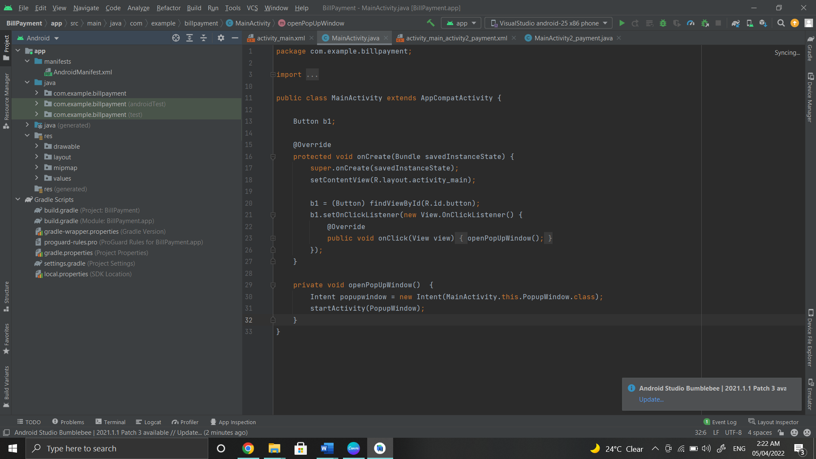

By default, Android Studio displays our project files in the Android project view, as shown in the above image.

These build files are visible to the top-level under Gradle Scripts. And the app module contains the following folders:

* **manifests:** It contains the AndroidManifest.xml file.
* **java:** It contains the source code of Java files, including the JUnit test code.
* **res:** It contains all non-code resources, UI strings, XML layouts, and bitmap images.

**Android Studio User Interface**

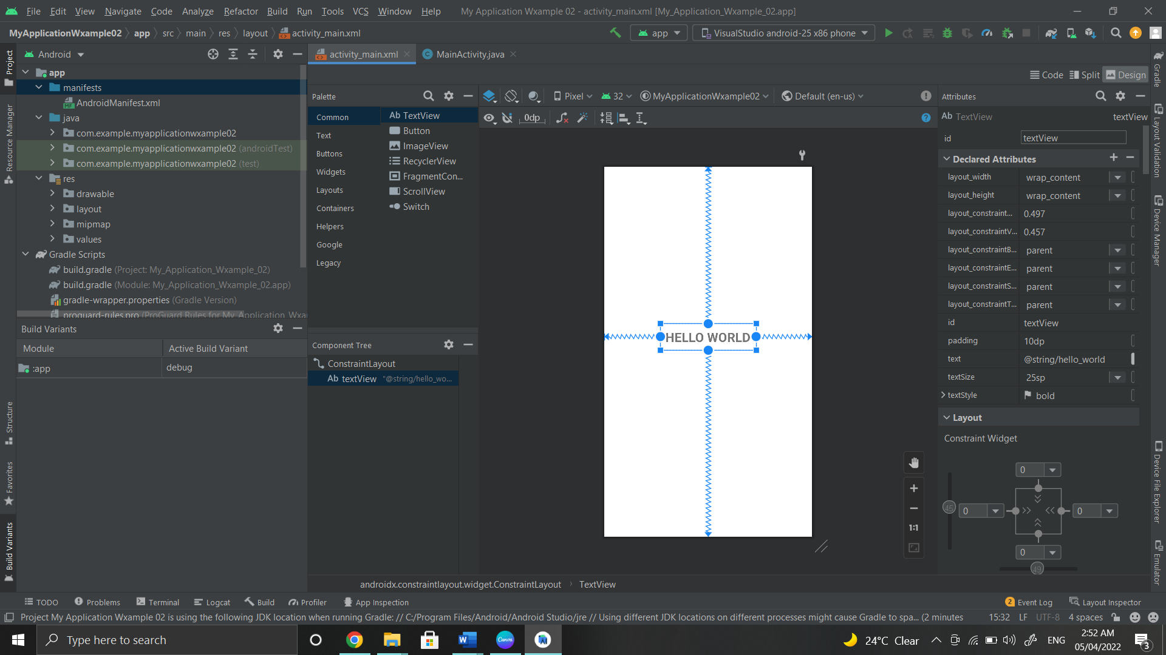

1. The **toolbar** provides us a wide range of actions, which includes running apps and launching Android tools.
2. The **navigation bar** helps in navigating our project and open files for editing. It gives a compact view of structure visible in the Project window.
3. The **editor window** is a space where we can create and modify our code. On the basis of the current file type, the editor can change. While viewing a layout file, the editor displays the Layout Editor.
4. The **tool window bar** runs around the outside the IDE window and contains buttons that allow as to expand and collapse individual tool windows.
5. The **tool windows** provide us access specific tasks like search, project management, version control, and more. We can able expand and collapse them.
6. The **status bar** displays the status of our project and IDE itself, as well as any messages or warnings.

**3.3.2 GOOGLE CLOUD PLATFORM**



**Google Cloud** is a suite of Cloud Computing services offered by Google. The platform provides various services like compute, storage, networking, Big Data, and many more that run on the same infrastructure that Google uses internally for its end users like Google Search and YouTube.

Google Cloud has been one of the top cloud providers in the IT industry. The services they offer can be accessed by software developers, as it provides a reliable and highly scalable infrastructure to build, test, and deploy.

**3.3.3 SQLite DATABASE**



**SQLite** **Database** is an open-source database provided in Android which is used to store data inside the user’s device in the form of a Text file. We can perform so many operations on this data such as adding new data, updating, reading, and deleting this data. SQLite is an offline database that is locally stored in the user’s device and we do not have to create any connection to connect to this database.

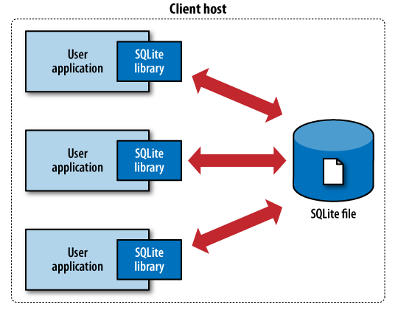

**4. LIBRARIES AND PACKAGES**

LIBRARIES

AND

PACKAGES

**4.1 FIREBASE AUTHENTICATION**

We can use Firebase Authentication to sign in a user by letting the user use their Email and password as their login credentials.

**4.2 REALTIME DATABASE**

It provides services to implement a firebase realtime database.

**4.3 CLOUD FIRESTORE**

It provides services to implement firebase firestore.

**4.4 CLOUD STORAGE**

It provides services to store image files, audio files as well as video files.



PROJECT OVERVIEW

**5. PROJECT OVERVIEW**

The system’s GUI as well as the overall development of the application is done using Android Studio. We have integrated various libraries and packages to the project which includes Firebase Authentication, Realtime Database, Cloud Firestore and Cloud Storage.

***HOMEPAGE***

The HOMEPAGE contains an image slider which uses the cloud storage to store the image files which connects to Firestore using URL. The Global Positioning System (GPS) location uses the SDK provided by the Google Cloud Platform.

***LOGIN/REGISTER/NEW USER***

Firebase Auth is used to authenticate the user who has already registered and lets the user to login and logout whenever they want. For mobile verification, we made use of firebase phone authentication. Only the members present in the database will be allowed to create/register the account.

Firebase Realtime Database is used to create and store the database of the user.

The LOGIN, PROFILE, COMPLAINTS, BILL PAYMENTS, INTERCOM and SOCIETY MEMBERS modules make use of Realtime Database.

The PROFILE, CIRCULARS and COMPLAINTS modules use Firebase Storage which is used to store all the image files which will be connected to the Realtime Database using an URL.

The PARKING, DELIVERY, STAFF, EMERGENCY CONTACTS, VENDORS and VISITORS modules have the search bar to search through the data. These modules make use of Realtime Database to store the data except EMERGENCY CONTACTS module which makes use of SQLite Storage that enables to store the offline data in case of emergencies.



**6. DATA HANDLING**

DATA HANDLING

**6.1 DATA FLOW DIAGRAM**

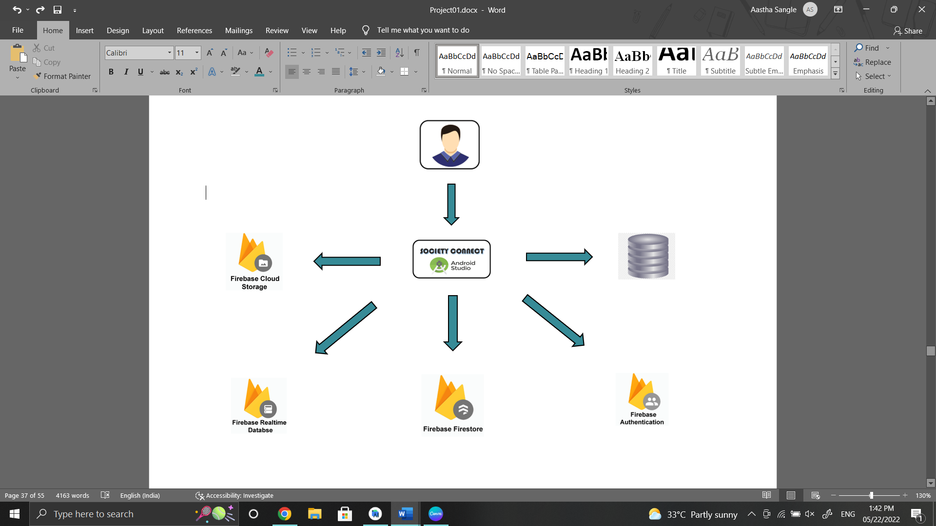

Inform /Check Payments

BILL PAYMENT

SQL lite



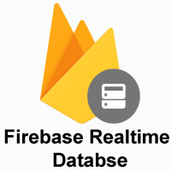



Communicate with Members

INTER-COM

Response

ADD CIRCULAR

LOGIN

Manage a complaint

Add/ Update Society Members

Response

Response

Response

Response

Request to Login

Response

Add Circular

CHECK SOCIETY MEMBERS

MANAGE COMPLAINTS

DATA RETRIVED

DATA INSERTED





ADMIN

* 1. **USE CASE DIAGRAM**

**Home**

**Login**

**Parking**

`1

**Society Members**

**Inter-Com**

**Complain**

**Emergency Contact**

**ADMIN**



**Bill Payments**

**Vendors**

**Staff**

**Circular**

**Visitor**

**Delivery**

**VISITORS**

**MEMBERS**

**SECURITY**



USER

MANUAL

**7. USER MANUAL**

* 1. **Splash Screen**

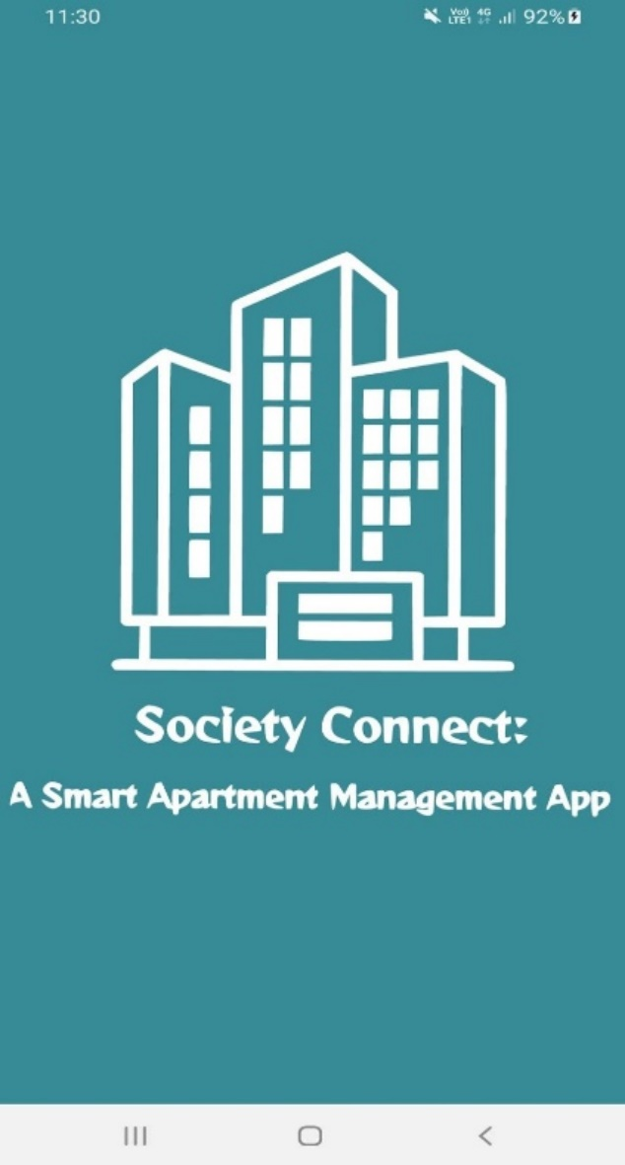

When “***Society Connect: A Smart Apartment Management Application”*** apk is downloaded and installed on your device, a splash screen will be displayed as shown above.

* 1. **HOME SCREEN**

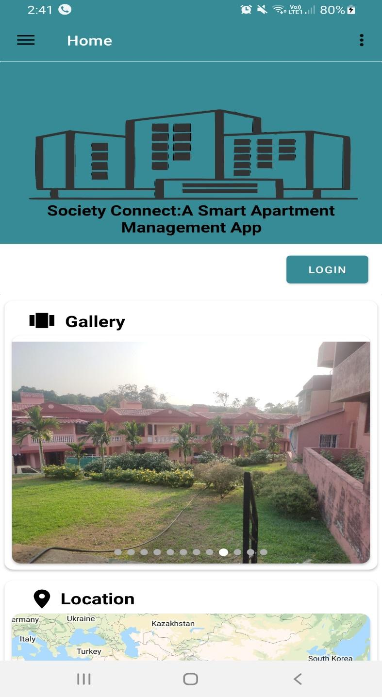

The user will be directed to **Home** **Screen**.

The home screen is comprised of;

* Gallery
* Location
* Contact Us
* Social Media

To access all the features in the application, the user will have to login by clicking on “**LOGIN**”.

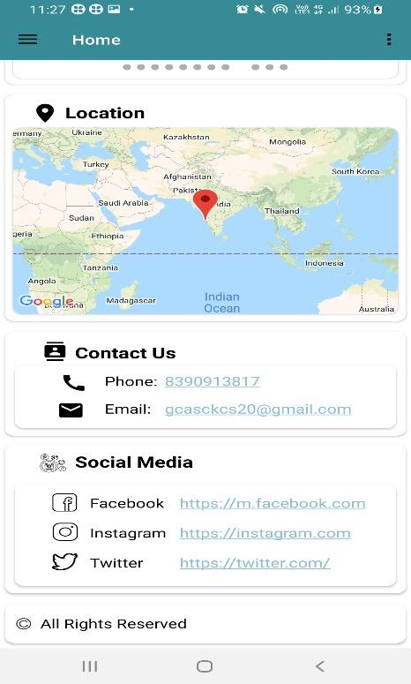

This Thick hamburger menu bar line art vector icon for apps and websites three-line button at the top-left corner will slide side of the screen and reveal the hidden menu with list of options.

1. *Gallery* section consists of the pictures of the society.
2. *Location* section gives the live location of the society on the Google Map.
3. *Contact Us* provides with the Phone/Mobile number and Email of the authorized member of the society.
4. *Social Media* section provides with the links to connect to Facebook, Instagram and Twitter, the official accounts of the society.

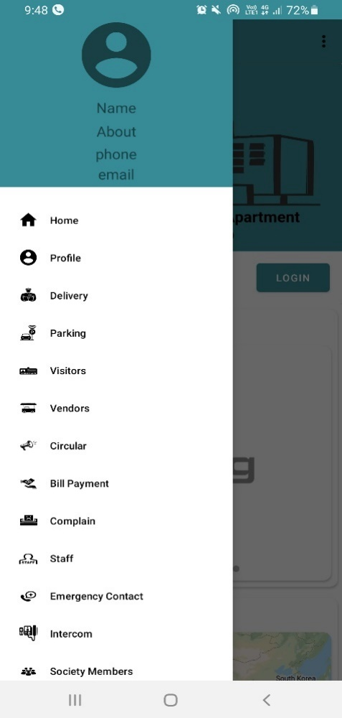

* The Thick hamburger menu bar line art vector icon for apps and websites hidden menu consists of various features for the users to access.
* After the user has completed the login procedure, he/she has to fill in the profile details and then the menu will display the respective fields : Name, About, Phone number and Email of the user.
* **Features include:** *Home*, *Profile*, *Delivery*, *Parking*, *Visitors*, *Circular*, *Bill Payment*, *Complain*, *Staff*, *Emergency Contact*, *Intercom* and *Society Members*.
* To open any activity in the menu, click on the particular activity you want to launch.
  1. **LOGIN/REGISTER**

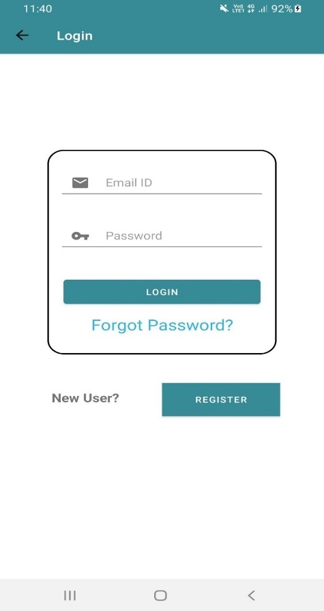

If the user has already registered, he/she will have to login with Email and password.

* The user should enter correct email and password and then hit the button “**LOGIN**”.
* After the user has logged in, it will take you back to the **HOME PAGE**.
* In case, the user forgot the password, click on the button “**Forgot Password?**” to set a new password.
* If it is a new user, the user will have to first register themselves by clicking on “**REGISTER**”.

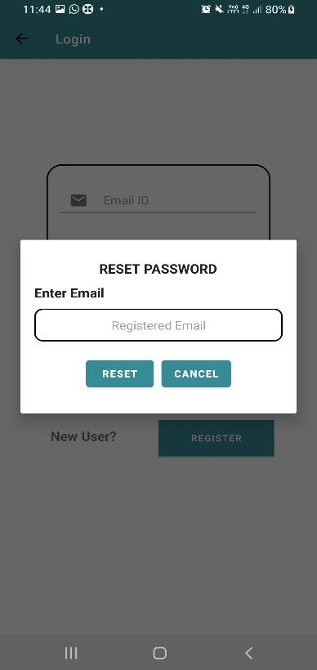

* To set a new password, the user should enter their registered Email ID.
* Click on “**RESET**” to set the new password.

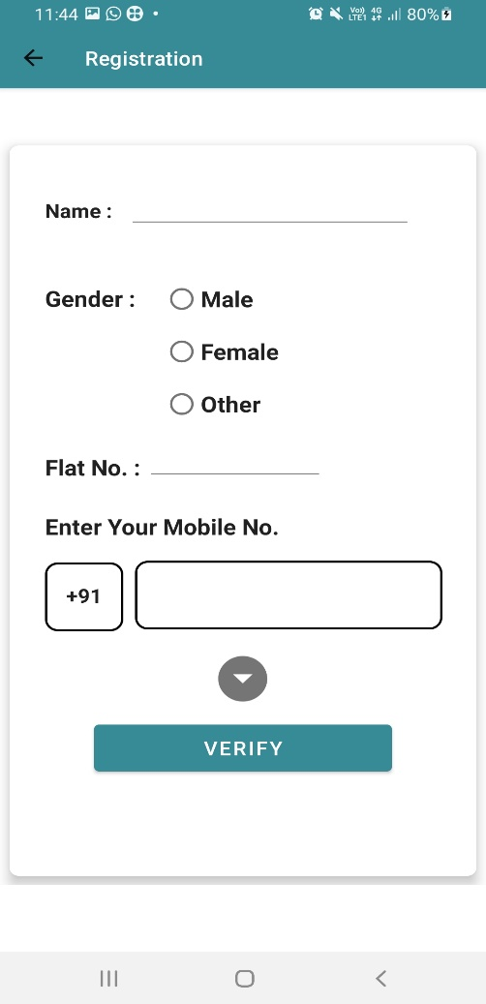

For new registration the user has to provide with the following;

* Name of the user.
* Gender (Male/Female/Other)
* Flat Number.
* Mobile Number.
* Click on “**VERIFY**” to verify your mobile number.

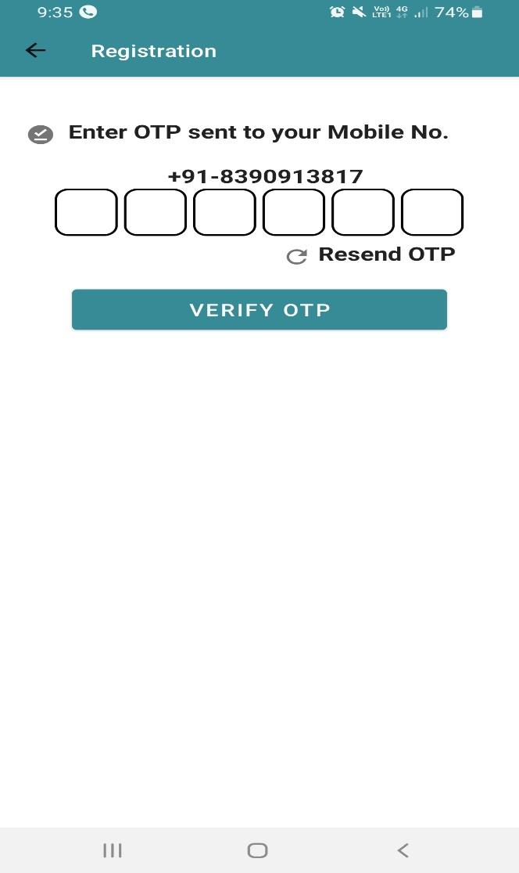

* An OTP will be sent to the mobile number provided via SMS.
* The user will have to check their inbox and provide the 6-digit OTP number sent through the SMS in your mobile.
* In case the OTP is not sent, click on “**Resend OTP**” to get a new OTP.
* After providing the 6-digit OTP number, hit the button “**VERIFY OTP**”.

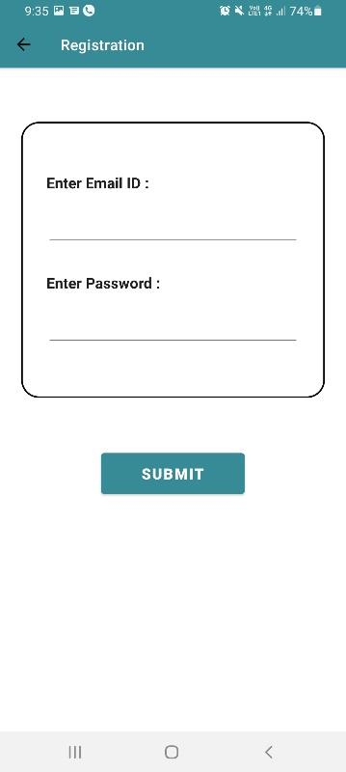

* After the mobile verification is completed, the user will be directed to login page.
* The user will have to enter their registered Email ID and password.
* Click on “**SUBMIT**” to complete the process.
  1. **DELIVERY**

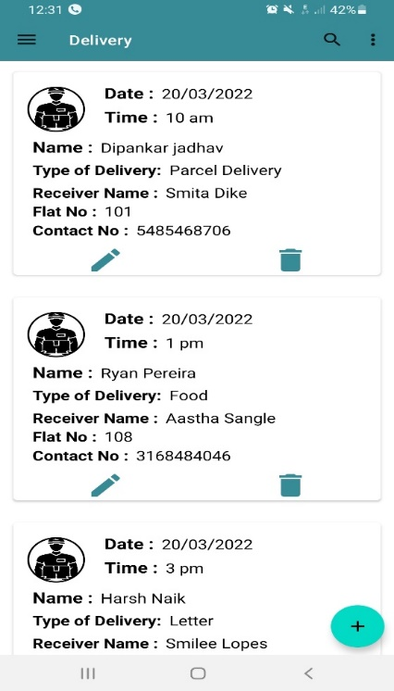

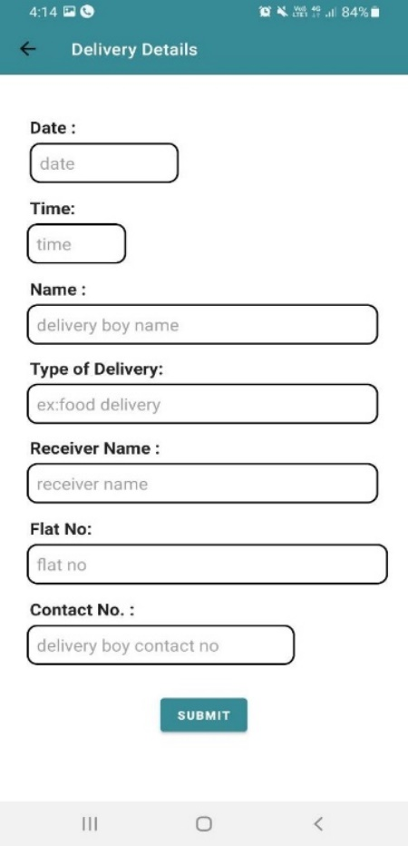

The system keeps track of all the deliveries done in the society.

The details include;

* Date
* Time
* Name of the delivery person
* Type of delivery
* Receiver’s name
* Flat Number.
* Contact Number.

To add new entry of the delivery, click on “+” button on the bottom right of the screen.

To add new delivery details, fill the following details;

* Date
* Time of the delivery.
* Name of the delivery person.
* Type of delivery.
* Enter the Receiver’s Name.
* Enter Flat number.
* Enter Contact Number.
* Click on “**SUBMIT**”.
  1. **PARKING**

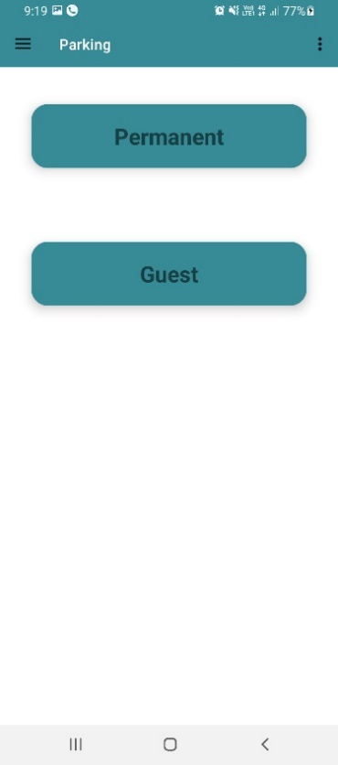

* The system tracks the parking allotted to the flat owners as well as the guests.
* There are parking slots allotted to each of the flat owners in the society and some allotted for the guest parking.
* To view the permanent parking details, click on “**Permanent**”.
* To view the guest parking details, click on “**Guest**”.
* The parking slots can be adjusted for guest parking if any of the permanent parking slot is available by checking the system.

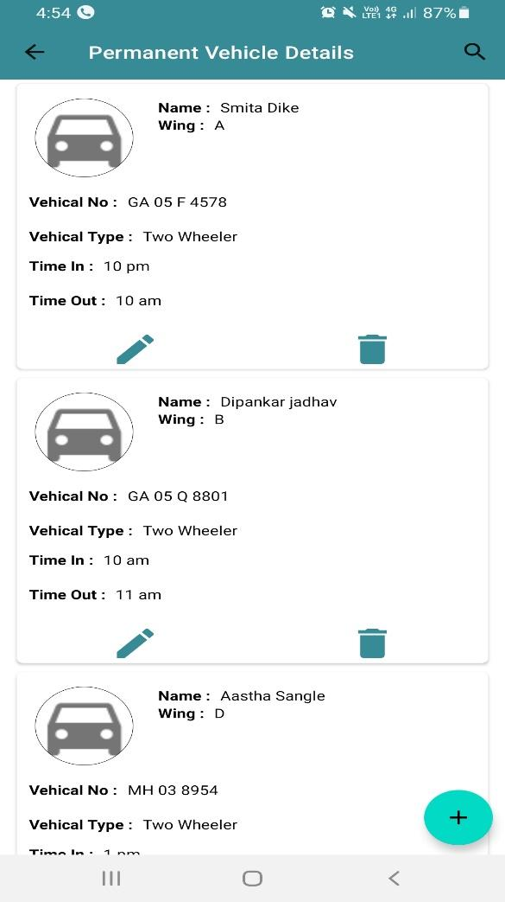

The system allows the dedicated authority to view the list of all the vehicles parked.

The details include:

* Name of the owner
* Wing
* Vehicle No.
* Time in
* Time out

To add new vehicle, click on the “+” button on the bottom right of the screen.

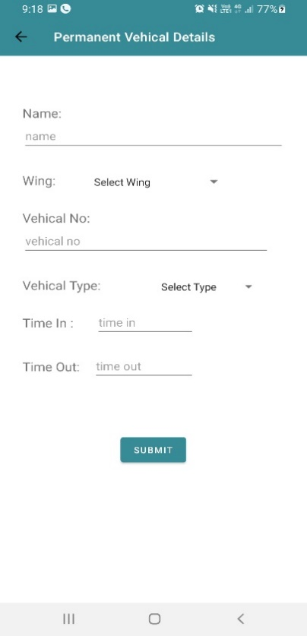

To add a new vehicle to the parking, fill the following details:

* Enter Name of the owner
* Wing (Select the wing from the drop-down menu).
* Enter the Vehicle number.
* Select the vehicle type from the drop-down menu.
* Mention the time in.
* Mention the time out.
* Click on “**SUBMIT**”.

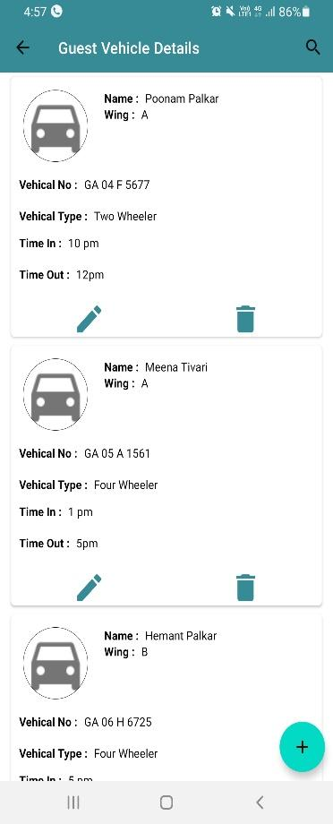

The system allows the dedicated authority to view the list of all the guest vehicles parked.

The details include:

* Name of the owner
* Wing
* Vehicle Number
* Vehicle Type
* Time in
* Time out

To add new vehicle, click on the “+” button on the bottom right of the screen.

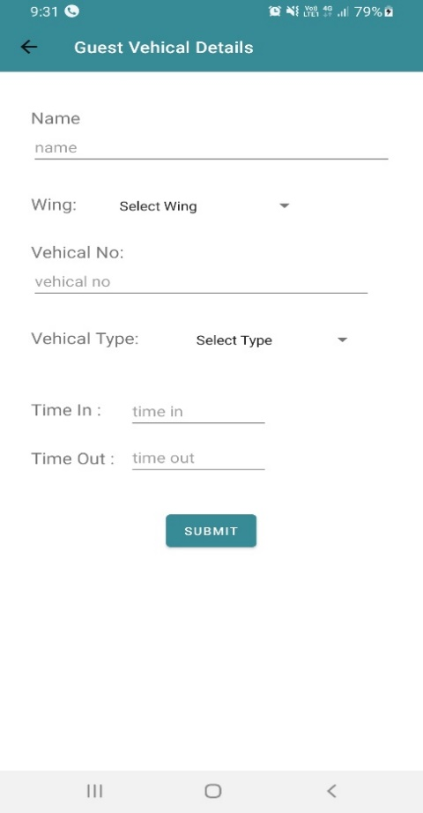

To add new guest vehicle entry to the parking, fill in the following details:

* Enter name of the owner.
* Wing (Select the wing from the drop-down menu).
* Enter the vehicle number.
* Select the vehicle type from the drop-down menu.
* Mention the time in.
* Mention the time out.
* Click on “**SUBMIT**”.

**6. VISITORS**

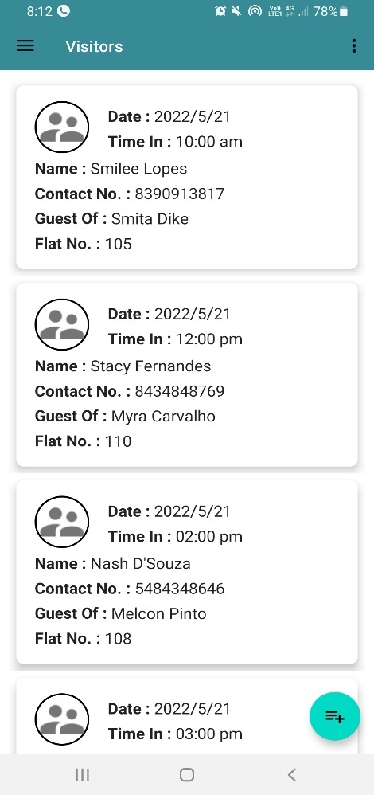

The system keeps track of all the Visitors entering the society.

The details include:

* Date
* Time In
* Name of the visitor
* Contact Number
* Guest of (Flat Owner)
* Flat number (Owner’s flat number)

To add a new entry to the visitors details, click on  the button at the bottom right of the screen.

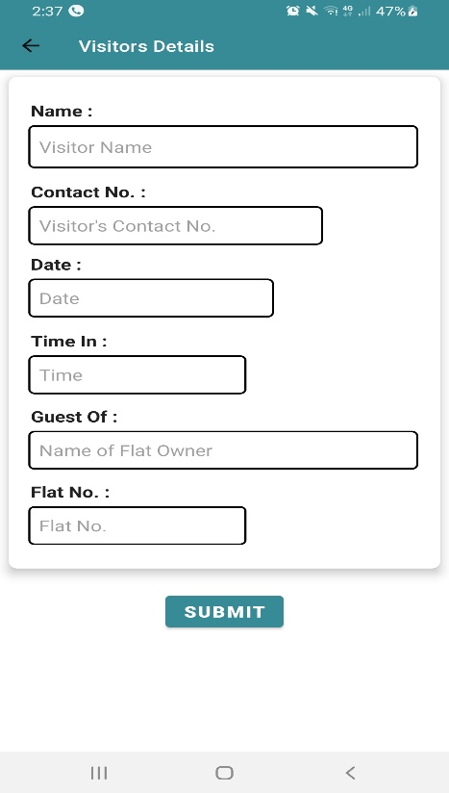

To add a new entry to the visitor’s details, fill the following fields:

* Enter Visitor’s Name
* Enter Contact number.
* Date of visiting.
* Time the visitor enters the society.
* Guest of (Flat Owner).
* Flat number.
* Click on “**SUBMIT**”

**7. VENDORS**

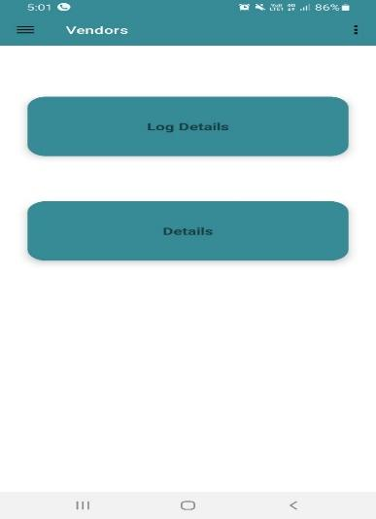

* The members can view the log details as well as the details of the vendors coming to the society.
* To view the log details of the vendors, click on “**Log Details**”.
* To view the details of the vendors, click on “**Details**”.

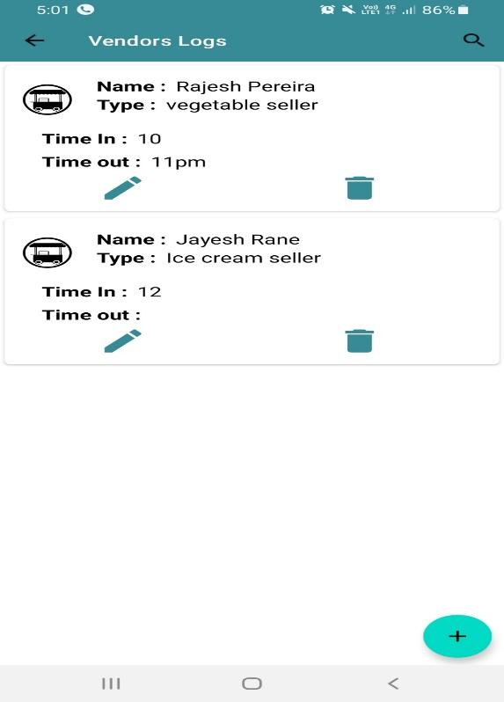

The members can view the list of vendor log details.

The details include;

* Name of the vendor
* Type (job description)
* Time in.
* Time out

To add new entry to the vendor logs, click on the “+” button on the bottom right of the screen.

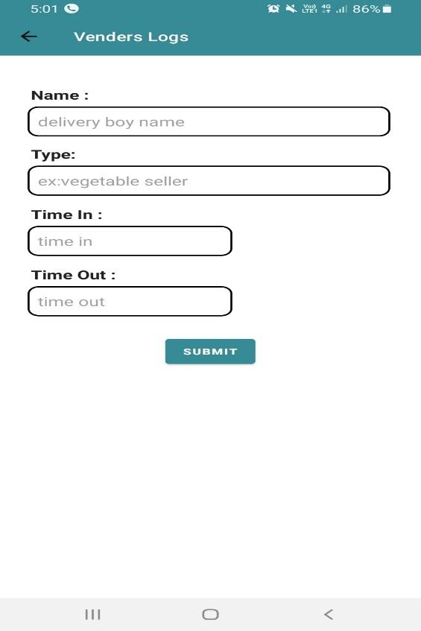

To add a new entry to the vendor logs, fill the following details:

* Enter delivery person’s name.
* Enter type of delivery.
* Mention time in.
* Mention time out.
* Click on “**SUBMIT**”.

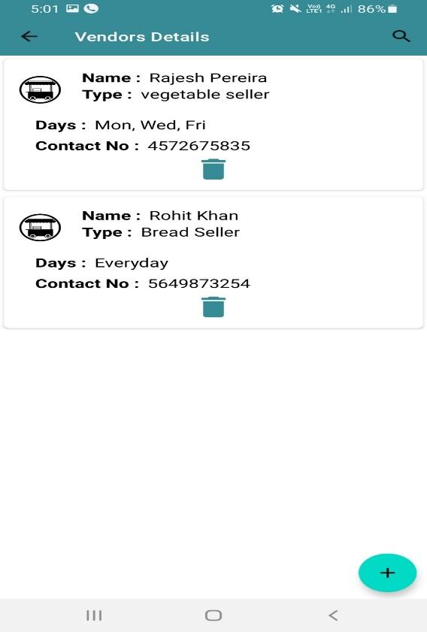

The members can view the list of vendor details.

The details include:

* Name of the vendor
* Type (Enter the job description)
* Vendor’s working days
* Contact number.

To add new entry to the vendor details, click on the “+” button on the bottom right of the screen.

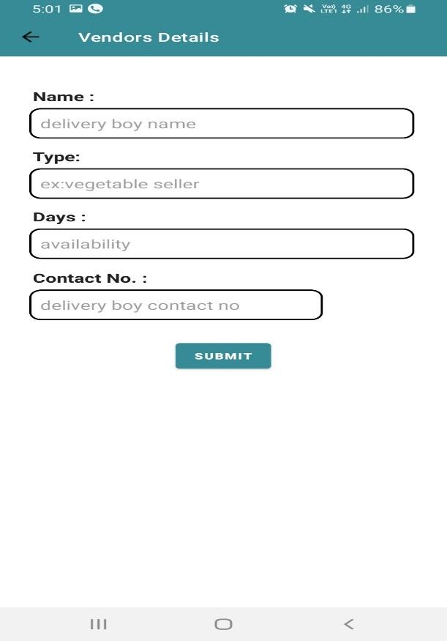

To add a new entry to the vendor details, fill the following details:

* Enter delivery person’s name.
* Enter type of delivery.
* Enter days of availability.
* Enter contact number.
* Click on “**SUBMIT**”.

**8. CIRCULARS**

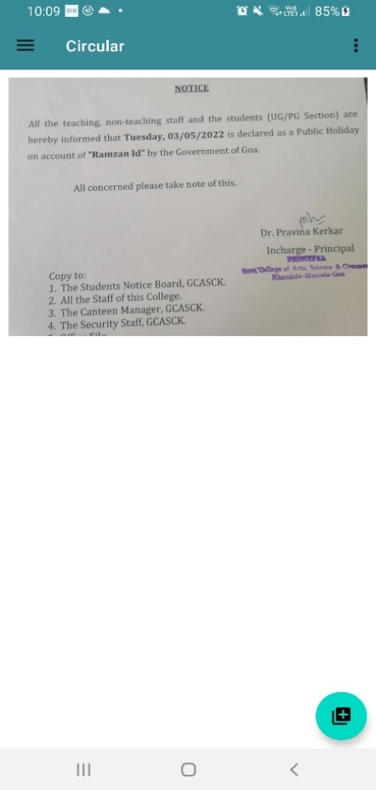

* The user can view all the circulars related to various events.
* To add more circulars, click on  button on the bottom right corner of the screen.

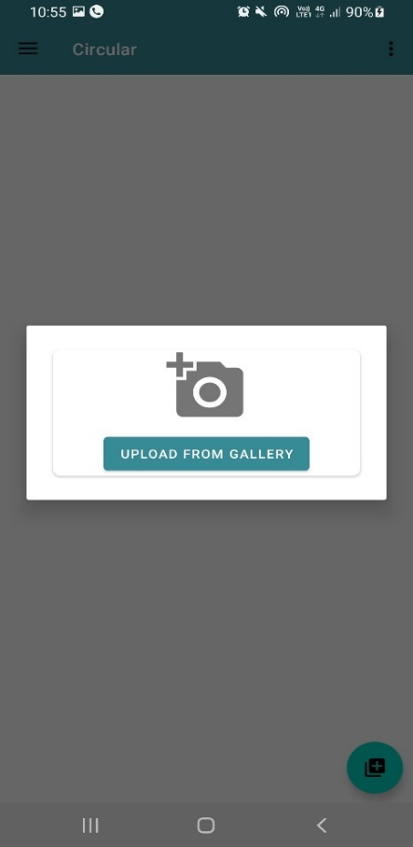

* Circulars can be uploaded as image files .

**9. STAFF**

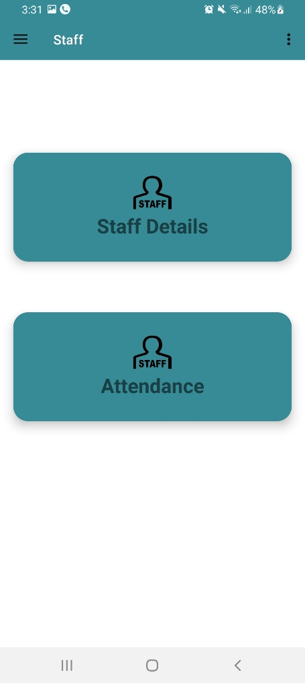

* The members can view the staff details and their availability everyday.
* Attendance of the staff will be recorded.
* To view the staff details, click on “**Staff Details**”.
* To view the attendance and availability of the staff, click on “**Attendance**”.

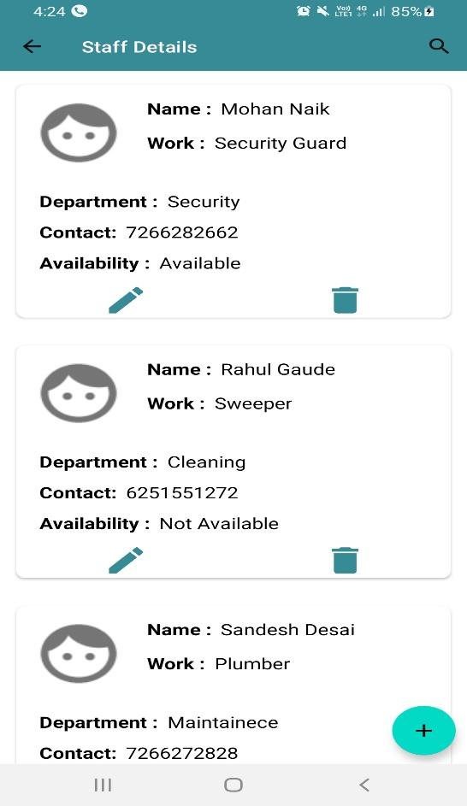

The members of the society can view the list of all the staff members registered.

The details of the staff include:

* Name
* Work
* Department
* Contact Number
* Availability

To add new staff member, click on the “+” button on the bottom right of the screen.

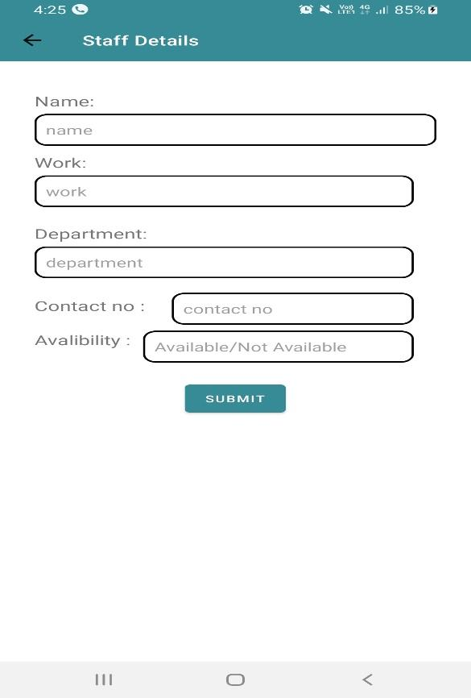

For staff details, fill the below details:

* Name
* Work
* Department
* Contact Number
* Availability
* Click on “**SUBMIT**”

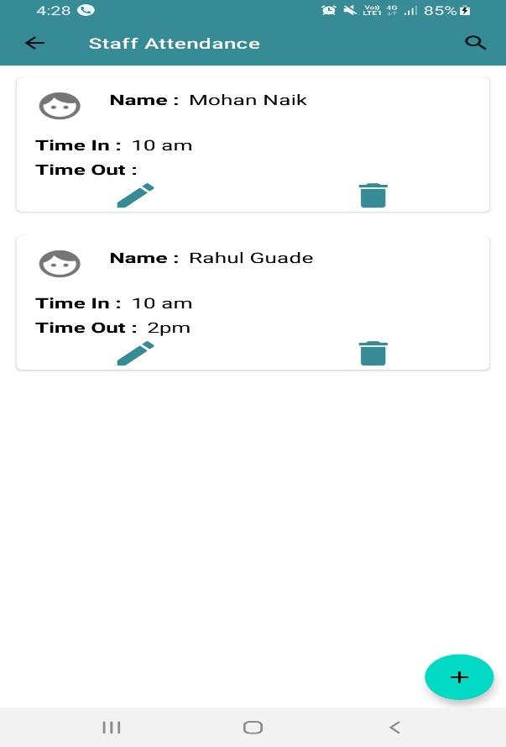

The members of the society can view the list of all the staff members log details.

The details include:

* Name
* Time in
* Time out

To add attendance, click on the “+” button on the bottom right of the screen.

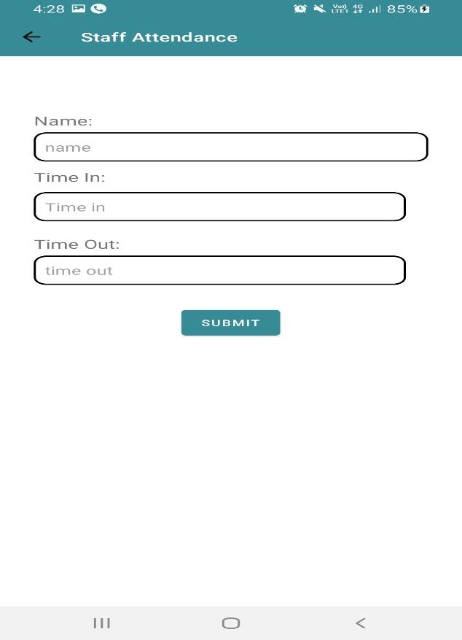

For attendance, fill in the below details:

* Enter staff member’s name.
* Time in.
* Time out.
* Click on “**SUBMIT**”.

**10. EMERGENCY CONTACTS**

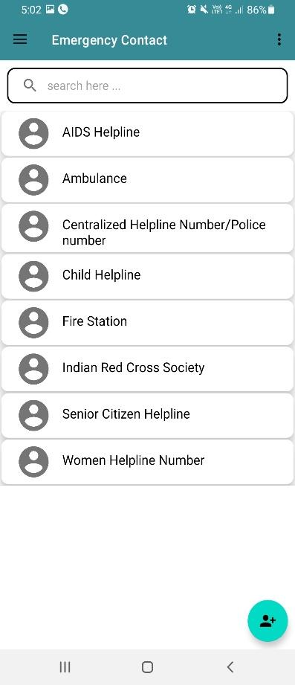

The members of the society can view the list of all the Emergency Contacts:

* Search the contact in the search bar.
* Click on the contact name that you want to call.
* After you click on the contact name, the contact information will be displayed as shown in the below image.
* Click on the calling button icon to make the call.
* To add new contact, click on the  button on the bottom right of your screen with a calling icon.

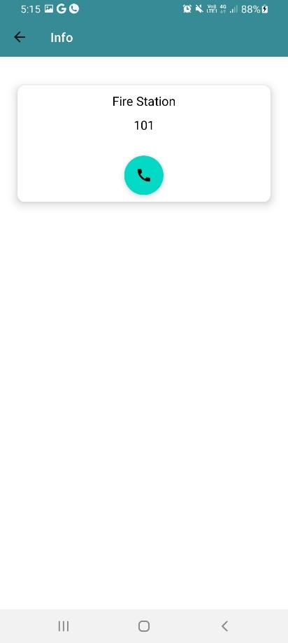

* Click on the calling button icon to make the call.

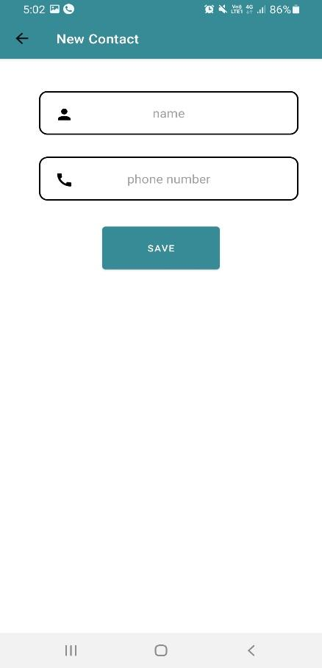

To add new contact information fill in the following details:

* Enter Name.
* Enter phone number.
* Click on “**SAVE**”.

**11. SOCIETY MEMEBRS**

The user can view the list of the society members according to their wings.

* To check the list of members in Wing A, click on “**Wing A**”.
* To check the list of members in Wing B, click on “**Wing B**”.
* To check the list of members in Wing C, click on “**Wing C**”.
* To check the list of members in Wing D, click on “**Wing D**”.

* The user can view the list of members in the particular wing.
* To add a new member, click on the “+” on the bottom right corner of the screen.

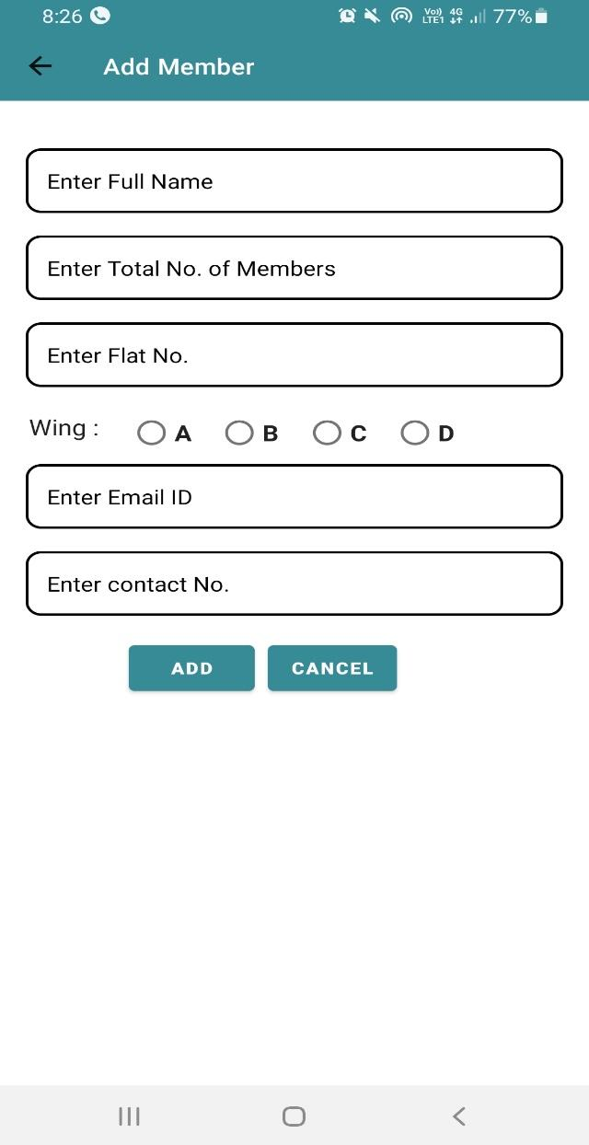

To add a new member to a particular wing, fill in the respective fields:

* Enter Full Name of the society member.
* Enter total number of family members
* Flat Number.
* Wing
* Email ID
* Contact Number.
* Click on “**ADD**”.

If the user wants to cancel the process, click on “**CANCEL**” and it will go back to the previous screen.

**8. FUTURE ENHANCEMENT**

FUTURE ENHANCEMENT

Our Project can be enhanced to a greater level by implementing new capabilities to existing system:

* Incorporating an automated system to interact with the users.
* Feature of chat bot where users can interact with the other users on the app.
* The Emergency Management System (EMS).
* QR Code scanning facility for keeping track of the attendance.
* Intercom facility over Wi-Fi.



BIBLIOGRAPHY

**9. BIBLIOGRAPHY**

1. **Downloaded ANDROID STUDIO:** [**https://developer.android.com/studio?gclsrc=aw.ds&gclid=Cj0KCQjwpcOTBhCZARIsAEAYLuUrrbVW8kuFOxsro1Jw-5ULT0QeaRqDagZZ09CZ5Gxmw6_MQVRuBrsaAs31EALw_wcB**](https://developer.android.com/studio?gclsrc=aw.ds&gclid=Cj0KCQjwpcOTBhCZARIsAEAYLuUrrbVW8kuFOxsro1Jw-5ULT0QeaRqDagZZ09CZ5Gxmw6_MQVRuBrsaAs31EALw_wcB)
2. **Downloaded INKSCAPE:** [**https://www.filehorse.com/download-inkscape-64/**](https://www.filehorse.com/download-inkscape-64/)
3. [**https://intellipaat.com/blog/what-is-google-cloud/**](https://intellipaat.com/blog/what-is-google-cloud/)
4. [**https://developer.android.com/studio/intro**](https://developer.android.com/studio/intro)
5. [**https://firebase.google.com/docs/database#:~:text=The%20Firebase%20Realtime%20Database%20is,realtime%20to%20every%20connected%20client**](https://firebase.google.com/docs/database#:~:text=The%20Firebase%20Realtime%20Database%20is,realtime%20to%20every%20connected%20client)**.**
6. [**https://firebase.google.com/docs/firestore**](https://firebase.google.com/docs/firestore)
7. [**https://www.techlearning.com/how-to/what-is-canva-and-how-does-it-work-for-education**](https://www.techlearning.com/how-to/what-is-canva-and-how-does-it-work-for-education)
8. [**https://www.techopedia.com/definition/32364/adobe-photoshop**](https://www.techopedia.com/definition/32364/adobe-photoshop)

